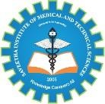

SIMATS ENGINEERING

Saveetha Institute of Medical and Technical Sciences
Chennai- 602105

Student Name: A K Selva Prabhu Reg. No.: 192421224
Course Code: CSA1403 Slot: C
Course Name: Compiler Design

Course Faculty: Dr. G. Michael

Project Title: Smart Compiler with AI-Based Syntax Error Detection and Auto Correction
Module Photographs:
 | SYSTEM ARCHITECTURE | MODULE DESIGN | PRESENTATION IMAGE
 | 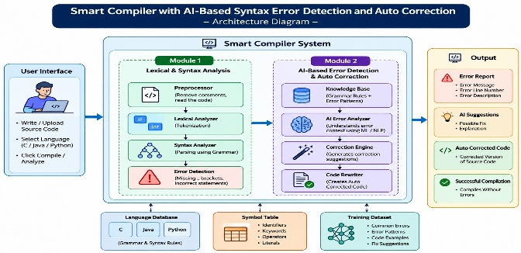 | 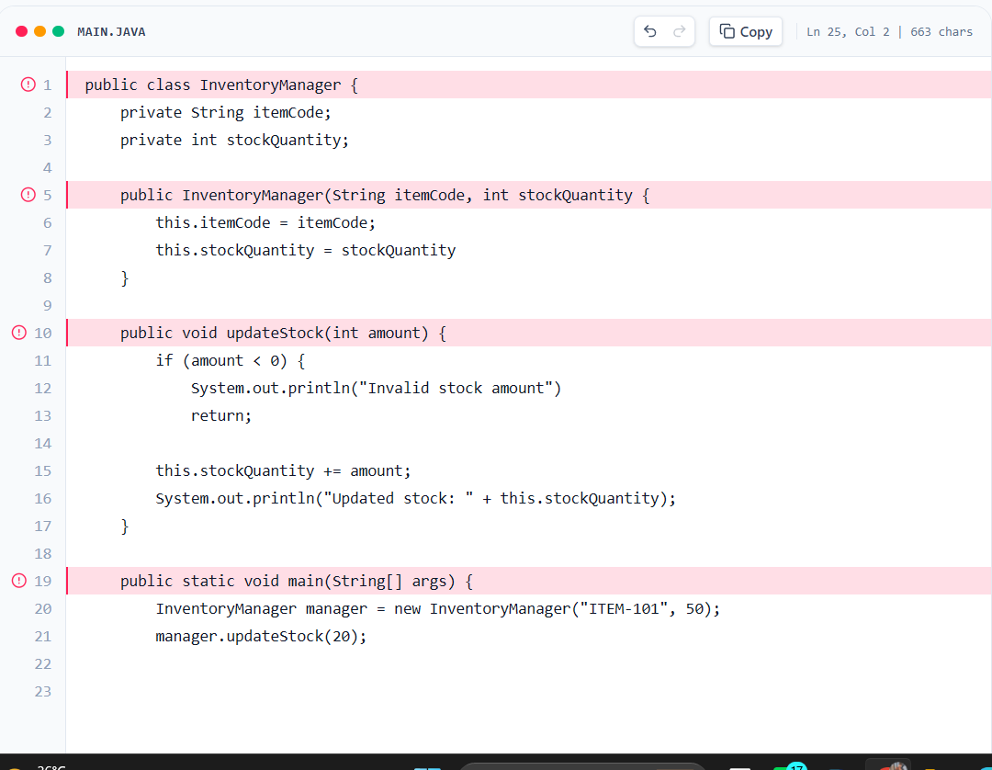 | 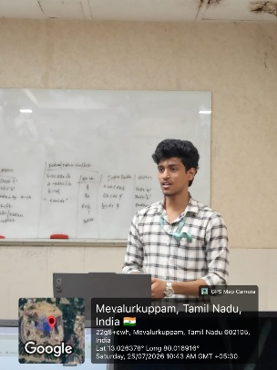
Project Description:
My primary responsibility in this project was Module 1 – Lexical & Syntax Analysis. The most difficult engineering problem was creating useful syntax feedback without implementing a complete parser for every supported language. I addressed this by using a lightweight local scan with bracket tracking, string checks, comment awareness and selected language heuristics. A key decision was to keep the basic diagnostic path local so that common errors could still be detected when the AI service was unavailable. Through this work I developed a better understanding of how compiler concepts can be converted into practical software components. If the project were repeated, I would extend the module with formal tokenization and AST-based parsing so that the diagnostics become more language-aware and less heuristic.

Student Signature Guide Signature

